- Explain different types of Errors in Java.
Ans. i) Syntax Error/ Compile Time mistakes
ii) Logical Error/ Run Time Mistakes

- What is an Exception in Java?
Ans. An unwanted/ unexpected event that disturb the normal flow of execution of a program is called “Exception handling”.

- How can you handle exceptions in Java? Explain with an example.
Ans. Exception handling can be perform using “Try, Catch, Finally” blocks.

- Why do we need exception handling in Java?
Ans. Exception handling ensures the smooth running of a program without program termination.

- What is the difference between exception and error in Java?
Ans.
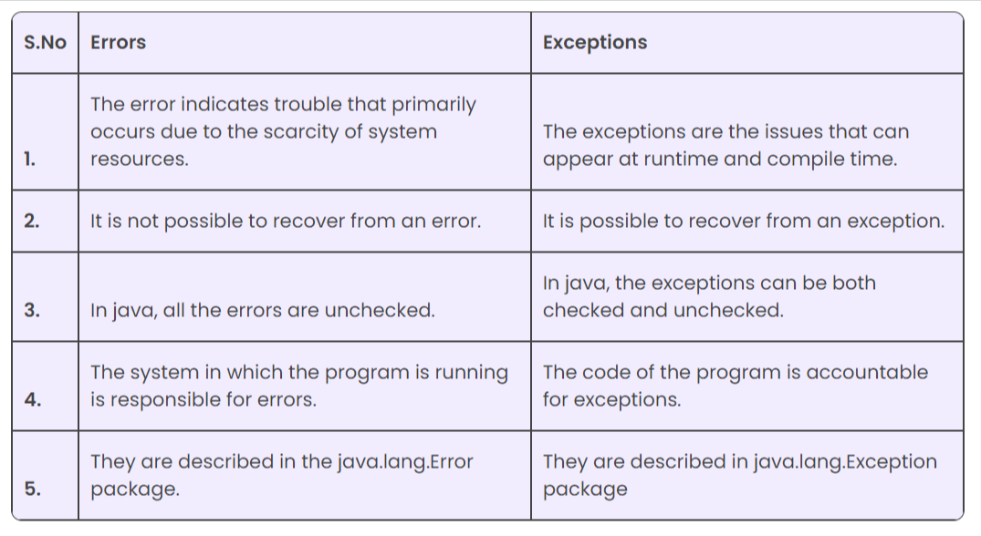

- Name the different types of exception in Java.
Ans. Two type of exceptions in java:
Checked : Occur during the compilation.
Unchecked: Occur during program execution.

- Can we just use try instead of finally and catch blocks? Give an example.
Ans. No, doing so will show a compilation error. Catch or finally block must always accompany try block. We can remove either finally block or catch block, but never both.

